# Flow Documentation - ControloParental-31828679-4EF3-EE11-A1FD-0022489FEA43

|  |  |
| --- | --- |
| **Flow Name** | ControloParental-31828679-4EF3-EE11-A1FD-0022489FEA43 |
| **Documentation generated at** | 22 May 2024 11:07 |
| **Number of Variables** | 0 |
| **Number of Actions** | 4 |

## Flow Overview

The following chart shows the top level layout of the Flow. For a detailed view, please visit the section called Detailed Flow Diagram

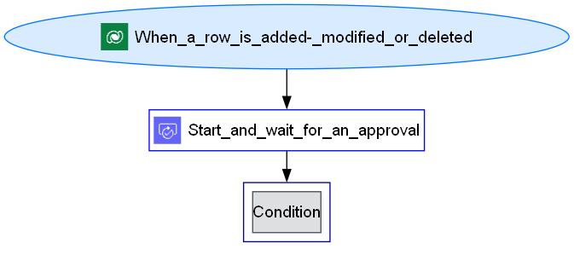

## Connections

There are a total of 4 connections used in this Flow:

### shared

|  |  |
| --- | --- |
| **Connector** | [shared](https://docs.microsoft.com/connectors/shared) |
| **Connection Type** | ConnectorReference |
| **Connection Reference Name** | cr058_sharedcommondataserviceforapps_cd24a |
| **Source** | embedded |

## Variables

## Trigger

|  |  |
| --- | --- |
| **Name** | When_a_row_is_added,_modified_or_deleted |
| **Type** | OpenApiConnectionWebhook |
| **Connector** | commondataserviceforapps |
| **Inputs Details** | |
| **parameters** | |  |  | | --- | --- | | subscriptionRequest/message | 1 | | subscriptionRequest/entityname | cr058_cadastro_ginasio | | subscriptionRequest/scope | 4 | | subscriptionRequest/name | 31828679-4ef3-ee11-a1fd-0022489fea43 | |
| **host** | |  |  | | --- | --- | | apiId | /providers/Microsoft.PowerApps/apis/shared_commondataserviceforapps | | operationId | SubscribeWebhookTrigger | | connectionName | shared_commondataserviceforapps | |

## Actions

There are a total of 4 actions used in this Flow:

### Condition

|  |  |
| --- | --- |
| **Name** | Condition |
| **Type** | If |
| **Expression** | |  |  |  |  | | --- | --- | --- | --- | | and | |  |  | | --- | --- | | startsWith | @body('Start_and_wait_for_an_approval')?['outcome']  A | | |
| **Elseactions** | Send_an_email_(V2)_1  Delete_a_row |

### Delete_a_row

|  |  |
| --- | --- |
| **Name** | Delete_a_row |
| **Type** | OpenApiConnection |
| **Connection** | |  |  | | --- | --- | |  | [Microsoft Dataverse](https://docs.microsoft.com/connectors/commondataserviceforapps) | |
| **Inputs** | |
| **parameters** | |  |  | | --- | --- | | entityName | cr058_cadastro_ginasios | | recordId | @triggerBody()?['cr058_cadastro_ginasioid'] | |
| **host** | |  |  | | --- | --- | | apiId | /providers/Microsoft.PowerApps/apis/shared_commondataserviceforapps | | operationId | DeleteRecord | | connectionName | shared_commondataserviceforapps-1 | |

### Send_an_email_(V2)_1

|  |  |
| --- | --- |
| **Name** | Send_an_email_(V2)_1 |
| **Type** | OpenApiConnection |
| **Connection** | |  |  | | --- | --- | |  | [Office 365 Outlook](https://docs.microsoft.com/connectors/office365) | |
| **Inputs** | |
| **parameters** | |  |  | | --- | --- | | emailMessage/To | @triggerBody()?['cr058_responsavelmenor'] | | emailMessage/Subject | Inscrição rejeitada | | emailMessage/Body | <p>A sua inscrição foi rejeitada</p> | | emailMessage/Importance | Normal | |
| **host** | |  |  | | --- | --- | | apiId | /providers/Microsoft.PowerApps/apis/shared_office365 | | operationId | SendEmailV2 | | connectionName | shared_office365 | |
| **Next Action(s) Conditions** | Delete_a_row [Succeeded] |

### Start_and_wait_for_an_approval

|  |  |
| --- | --- |
| **Name** | Start_and_wait_for_an_approval |
| **Type** | OpenApiConnectionWebhook |
| **Connection** | |  |  | | --- | --- | |  | [Approvals](https://docs.microsoft.com/connectors/approvals) | |
| **Inputs** | |
| **parameters** | |  |  | | --- | --- | | approvalType | Basic | | WebhookApprovalCreationInput/title | Aprovar Menor Inscrição | | WebhookApprovalCreationInput/assignedTo | @{triggerBody()?['cr058_responsavelmenor']} | | WebhookApprovalCreationInput/enableNotifications | True | | WebhookApprovalCreationInput/enableReassignment | True | |
| **host** | |  |  | | --- | --- | | apiId | /providers/Microsoft.PowerApps/apis/shared_approvals | | operationId | StartAndWaitForAnApproval | | connectionName | shared_approvals-1 | |
| **Next Action(s) Conditions** | Condition [Succeeded] |

## Detailed Flow Diagram

The following chart shows the detailed layout of the Flow

